New Wheels Project

Introduction to SQL

Problem Statement
Business Context
A lot of people in the world share a common desire: to own a vehicle. A car or an automobile is seen as an object that gives the freedom of mobility. Many now prefer pre-owned vehicles because they come at an affordable cost, but at the same time, they are also concerned about whether the after-sales service provided by the resale vendors is as good as the care you may get from the actual manufacturers.
New-Wheels, a vehicle resale company, has launched an app with an end-to-end service from listing the vehicle on the platform to shipping it to the customer's location. This app also captures the overall after-sales feedback given by the customer.
Objective
New-Wheels sales have been dipping steadily in the past year, and due to the critical customer feedback and ratings online, there has been a drop in new customers every quarter, which is concerning to the business. The CEO of the company now wants a quarterly report with all the key metrics sent to him so he can assess the health of the business and make the necessary decisions.
As a data analyst, you see that there is an array of questions that are being asked at the leadership level that need to be answered using data. Import the dump file that contains various tables that are present in the database. Use the data to answer the questions posed and create a quarterly business report for the CEO.

Business Questions

Question 1: Find the total number of customers who have placed orders. What is the distribution of the customers across states?
Solution Query:
<Write your SQL query here>
Example:-
select *
from online_customer
where CUSTOMER_GENDER = ‘F’;

Output:
<Attach the screenshot of your output table>
- The screenshot should display 5-10 rows of the output
- Make sure the screenshot contains the “SQL Query Passed” along with the output table.
- A sample screenshot is provided below.
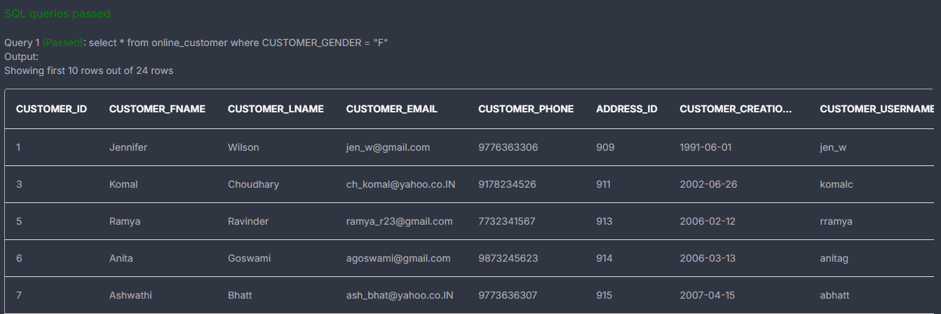

Observations and Insights:

Question 2: Which are the top 5 vehicle makers preferred by the customers?
Solution Query:
<Write your solution query here>

Output:
<Attach the screenshot of your output table>
- The screenshot should display 5-10 rows of the output
- Make sure the screenshot contains the “SQL Query Passed” along with the output table.

Observations and Insights:

Question 3: Which is the most preferred vehicle maker in each state?
Solution Query:
<Write your solution query here>

Output:
<Attach the screenshot of your output table>
- The screenshot should display 5-10 rows of the output
- Make sure the screenshot contains the “SQL Query Passed” along with the output table.

Observations and Insights:

Question 4: Find the overall average rating given by the customers. What is the average rating in each quarter?

Consider the following mapping for ratings: “Very Bad”: 1, “Bad”: 2, “Okay”: 3, “Good”: 4, “Very Good”: 5
Solution Query:
<Write your solution query here>

Output:
<Attach the screenshot of your output table>
- The screenshot should display 5-10 rows of the output
- Make sure the screenshot contains the “SQL Query Passed” along with the output table.

Observations and Insights:

Question 5: Find the percentage distribution of feedback from the customers. Are customers getting more dissatisfied over time?
Solution Query:
<Write your solution query here>

Output:
<Attach the screenshot of your output table>
- The screenshot should display 5-10 rows of the output
- Make sure the screenshot contains the “SQL Query Passed” along with the output table.

Observations and Insights:

Question 6: What is the trend of the number of orders by quarter?
Solution Query:
<Write your solution query here>

Output:
<Attach the screenshot of your output table>
- The screenshot should display 5-10 rows of the output
- Make sure the screenshot contains the “SQL Query Passed” along with the output table.

Observations and Insights:

Question 7: Calculate the net revenue generated by the company. What is the quarter-over-quarter % change in net revenue?
Solution Query:
<Write your solution query here>

Output:
<Attach the screenshot of your output table>
- The screenshot should display 5-10 rows of the output
- Make sure the screenshot contains the “SQL Query Passed” along with the output table.

Observations and Insights:

Question 8: What is the trend of net revenue and orders by quarters?
Solution Query:
<Write your solution query here>

Output:
<Attach the screenshot of your output table>
- The screenshot should display 5-10 rows of the output
- Make sure the screenshot contains the “SQL Query Passed” along with the output table.

Observations and Insights:

Question 9: What is the average discount offered for different types of credit cards?
Solution Query:
<Write your solution query here>

Output:
<Attach the screenshot of your output table>
- The screenshot should display 5-10 rows of the output
- Make sure the screenshot contains the “SQL Query Passed” along with the output table.

Observations and Insights:

Question 10: What is the average time taken to ship the placed orders for each quarter?
Solution Query:
<Write your solution query here>

Output:
<Attach the screenshot of your output table>
- The screenshot should display 5-10 rows of the output
- Make sure the screenshot contains the “SQL Query Passed” along with the output table.

Business Metrics Overview
Total Revenue | Total Orders | Total Customers | Average Rating
<enter_value> | <enter_value> | <enter_value> | <enter_value>
Last Quarter Revenue | Last quarter Orders | Average Days to Ship | % Good Feedback
<enter_value> | <enter_value> | <enter_value> | <enter_value>

Business Recommendations

